Question

1. Create tables - 15 Marks
   1. Make a student table
   2. Make a Library table
   3. Make a Fees table

Create table with proper relations.

1. Add proper constraints with the No 1 question - 5 Marks
2. Write the differences between data and information - 10 Marks
3. In MySQL, Update and Delete query wasn’t executing, what was the reason and how to run those query? Write the code to enable the feature. (If you followed the class, you should know this). - 10 Marks

Answer the following questions with this table data. Table name Employee.

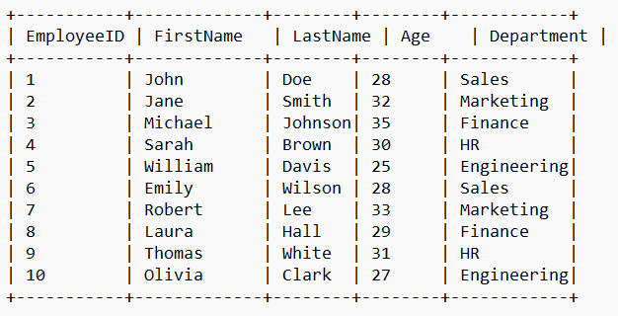

1. Write a query to show the distinct department names - 10 Marks
2. Write a query to show the LastNames of the employees sorted by descending ages - 10 Marks
3. Write a query to show the employee LastName whose age is greater than 30 and works in Marketing department. - 10 Marks
4. Write a query to select all the employees - 10 Marks
5. Write a query to get employees whose names includes ‘son’ - 10 Marks
6. Write a query to get the engineers - 10 Marks